Abraham Tent for Sarah and Abraham:

http://www.sundayschoolkids.com/activities-ot/abraham-tent-instructions.htm

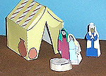
A Tent for Abraham and Sarah
This easy-to-make Bible times tent can also be a tent for Moses and the Exodus, Jacob's family, for Joseph stories, the prophets or other Bible stories. It can be a tent for David though mostly he stayed in caves when he was running from Saul.
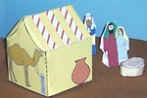
Easy Stand up tent.
Separate easy stand up Abraham with Sarah, Lot and Baby Isaac so you can support many of the Abraham stories. Or use the people as someone else!
The stand up tent has a camel "tied up" out back. Water jug at the side and grain jar near the doorway.
or color printer.
Grades: K-4
Cutting and gluing are quite easy for kindergarten, first grade and older.. Aligning the 2 tabs on the tent side should be done with care.( Preschool 3 and early 4 would need quite a bit of assistance.
Kids Sunday School Activity Genesis chapters 12 -22 Abram becomes Abraham. Abraham and Lot, Abraham and Sarah, Sarah gets a baby, Abraham and Isaac Material Checklist
Copies activity Page for each student
Scissors
White glue or glue stick
Crayons or Markers
Clear tape
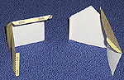
1, 3 and 4.

(time- about 15 minutes for precolored version)
Glue in sequence indicated
TENT
Make the tent first so it has a chance to dry.
1. Cut out both pieces of the tent
2. If you have the black and white version, color the tent pieces - suggestion that the both roof pieces are the same color, but it really doesn't matter. Do not color over the "Glue" spaces.
3. Write your name on the back of the tent paper. NOTE on the original page, the tops -or roofs of the tent are together so you have to turn one around so both the roofs are up ^. The camel and the pots should look upright.
4. FOLD on ALL DOTTED OR DASHED LINES
5. Put glue on glue space 1
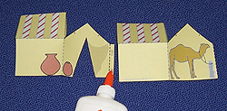
6. Align side 1 next to glue space number 1 .
7. Use a piece of paper or ruler to align the bottom of all the tent pieces straight.
8. Bring side 1 over glue flap 1
9. To strengthen the first joint, you may use tape on the back over the joint. At this time, you may also put a small piece of tape on the inside across the paper over the point of the doorway to avoid tearing.
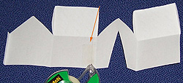
10. Re-fold on all lines
11. Put glue on glue space 2
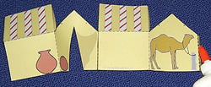
12. Bring side 2 around to cover glue space 2 ( You can then also carefully tape inside to hold this joint.)
13. Put glue on roof space 1. (You remembered to fold on this line before gluing?)
14. Bring the other roof piece up to cover the roof glue space.
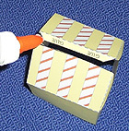
15. Gently pull out the 4 roof flaps over the front and back of the tent.
You're done!
BIBLE PEOPLE ARE ON A SEPARATE MICROSOFT WORD PAGE SO YOU MAY USE THE TENT ALONE FOR MANY OTHER OLD TESTAMENT STORIES YOU MAY ALSO USE THE PEOPLE AS ANY BIBLE CHARACTERS YOU CHOOSE
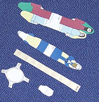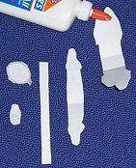
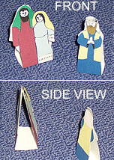
ABRAHAM, SARAH and LOT
1 Cut out all the pieces.
2 Color all the pieces if you have black and white version and/or put your name in the space on the bottom.
3. Fold on the dashed lines.
4. Glue on one end of the back of the paper (inside) on the back of the person's head
5. Bring the insides of the tops (blank sides) of the head together and press. Stand up your person. If needed, press harder on the dashed lines to make a flat bottom.
BABY ISAAC
1 Cut out baby Isaac
2 If you have the black and white version, color the blanket.
3 Cut out the basket base and long side strip
4. Fold the glue tabs up.
5 Wrap the long strip around the outside of the glue tabs to make a basket.
6. Put Isaac in the basket.
GET WHICHEVER MICROSOFT WORD PAGES YOU WANT BELOW:
You will be asked if you want to Open or Save the document, and you can choose whatever you want to do.
CLICK THIS BUTTON TO GET THE Colored TENT
CLICK THIS BUTTON TO GET THE Black and white TENT to color CLICK THIS BUTTON TO GET THE PEOPLE already colored CLICK THIS BUTTON TO GET THE PEOPLE to color - See more at: http://www.sundayschoolkids.com/activities-ot/abraham-tent-instructions.htm#sthash.gob9QF8V.dpuf

