https://drive.google.com/file/d/0B3uNEVAAKowpcVFrU0c1WXI2NW8/view
Beatitude flowers

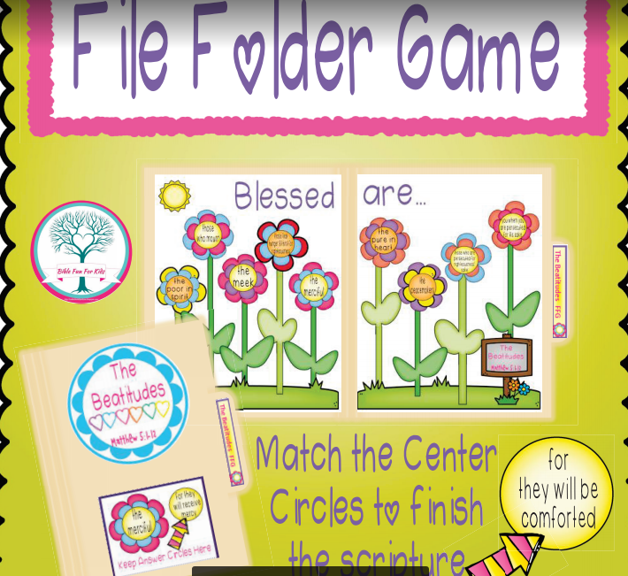

https://drive.google.com/file/d/0B3uNEVAAKowpNnl5QUxZaC1SYTA/view
Beatitude workshetts

https://drive.google.com/file/d/0B3uNEVAAKowpRlFseEpUVGNpWUk/view
Home-Schooling Beatitude Journal

https://drive.google.com/file/d/0B3uNEVAAKowpSTVQZmxreWxXc2s/view
Creaton Journal

https://drive.google.com/file/d/0B3uNEVAAKowpc3NGa1p2LS1zaVU/edit
OT books

https://drive.google.com/file/d/0B3uNEVAAKowpdlhQTGtYTDdmcTQ/edit
NT books

