HEROD THE GREAT
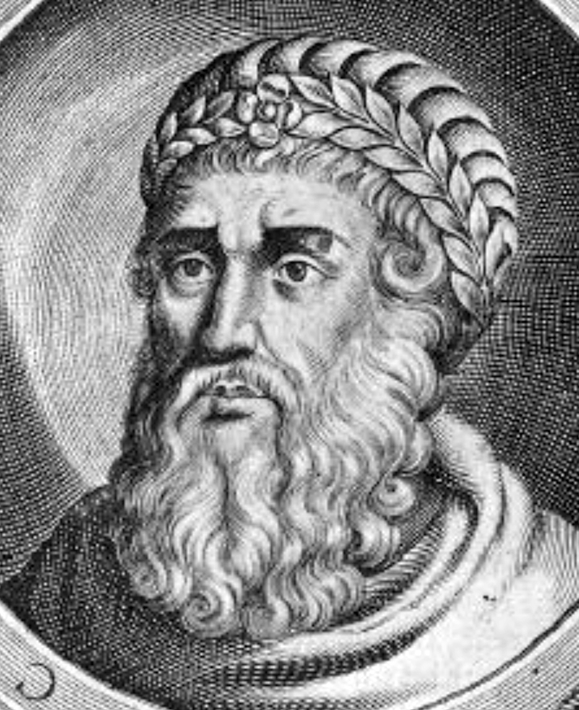

BACKGROUND
Herod the Great was King of Judaea from 37 B.C.E. to 4 C.E. He was born in 73 B.C.E. and grew up in a time of great political upheaval and unrest in Judaea. Being from an Idumaean background –- his mother was an ethnic Arab and his father was an Edomite –- Herod was always an outsider to the Jewish establishment. Although he was raised as a Jew, he lacked the social connections and priestly authority that a king of the Jews should have had. The Jews never really accepted him, and he stood with one foot in the Jewish religious culture and one foot in the Roman world; he was hated and resented by the general population of Jews. Herod’s loyalty swayed from one side of the Roman world to the other, at one point, becoming friends with both Marc Antony and Octavian, the young ambitious Roman leaders. While in Rome attempting to present himself as a loyal Roman underlord, Herod even offered a sacrifice to Roman pagan gods as an act of accommodation to the Roman authority he was voluntarily submitting to. With Rome’s help, after fighting in Judaea for three years, he was able to conquer Jerusalem and to hold Judaea politically.
Herod was a brilliant politician and spent his life amidst numerous civil wars and conspiracies, both with his own family members and with outside powerful enemies. He had a very large family: ten wives and more than twelve children. Over a period of time, he grew to be paranoid and suspicious of everyone, and had one loved wife murdered, her brother murdered, and even one or two of his sons. He was known to be a cruel tyrant; however, he was an extremely intelligent and creative man.
Herod was a master builder-engineer and patron of massive construction projects during his reign, such as Masada, Caesarea Maritima (a harbor city on the Mediterranean Sea), Herodium, the magnificent Temple in Jerusalem, and many other forts and palaces. He rebuilt the city of Jerusalem, bringing in architects from Rome to build a theater, hippodrome, baths, temples, palaces, etc.
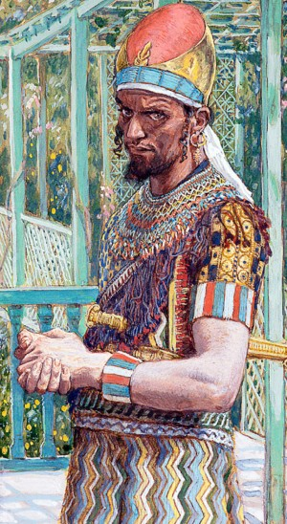Herod the Great was jealous of anyone whom he feared might take over his kingdom, hence his response to the Magi who told him they had come to Jerusalem to see a newly-born king. After Herod asks the chief priests and scribes “where Christ should be born” (Matt. 2:4,5), he orders his soldiers to slay the children of Bethlehem who were two years old or younger (Matt. 2:16). For a town the size of Bethlehem, probably only between six and twenty children would have been killed, with a dozen or so more in the surrounding areas. This event came to be known throughout the centuries as the “massacre of the innocents.”
“The slaughter of infants two years old or less in a town of the size of Bethlehem (population ca. 300) at this time would not only have been a comparatively minor incident, and so probably unknown to Josephus, the Jewish historian (37-100 C.E.), but also completely in line with Herod’s known character” (AB Matthew 19).
When he died, he wanted the kingdom to mourn for him. He knew they would not do that voluntarily, so he ordered his army to imprison a crowd of leading Judean citizens in the hippodrome in Jericho and see that they were massacred when his death was announced, so that the whole city would weep for him. When the time came to carry out the awful command, those in charge of the funeral preparations refused to do this and dismissed the Jews that were incarcerated in the hippodrome; nevertheless, one can see the bizarre cruelty that exemplified Herod’s reign.
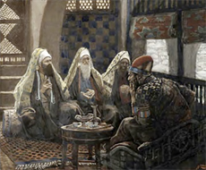After long months at his winter palace in Jericho, Herod died a horrible, painful death from “internal pains, burning sensations, swelling of feet, convulsions, ulcerated colon, putrefied and worm-eaten genitals, and very, very bad breath,” as described in Josephus (365). Scholars today believe he may have had syphilis, diabetes, chronic kidney disease, and gangrene.
He was taken to Herodium in a long funeral procession of five hundred servants carrying spices, his whole army in battle array, and his large family walking behind the procession for twenty-five miles.
The Herodium tomb was a hidden secret for over two thousand years until recently, when Ehud Netzer, a Jewish archaeologist, discovered the site of the tomb at Herodium. Today, it is in the process of being excavated.
Herod mentioned in the New Testament
Matt. 2:1-8
“…Jesus was born in Bethlehem of Judaea in the days of Herod the king…”
Matt. 2:12-15
Joseph takes his family to Egypt because “Herod will seek the young child to destroy him.”
Matt. 2:16-18
Herod slays all the male babies in Bethlehem.
Matt. 2:19-23
Herod dies and Joseph takes his family back to Israel and to Nazareth.
Sources:
The Anchor Bible: Matthew. Introduction, translation and notes by W. F. Albright and C. S. Mann. New York: Doubleday, 1971.
The Interpreter’s Dictionary of the Bible. Ed. George Arthur Buttrick et al. Nashville: Abingdon, 1989.
Jesus and His Times. Ed. Kaari Ward et al. Pleasantville: Reader’s Digest Assn., 1987.
Josephus. Complete Works of Josephus. William Whiston, trans. Grand Rapids: Kregel Publications, 1981.
Mueller, Tom. “The Holy Land’s Visionary Builder: Herod.” National Geographic, December 2008, 34-59.

