JOHN 18:38
A small piece of papyrus known as the "John Ryland Fragment" was discovered in 1934. This fragment is the earliest known New Testament document and has demonstrated that it was in curculation by A.D. 100. The words on the fragment are significant. They are from John 18 including the question "What is Truth?".
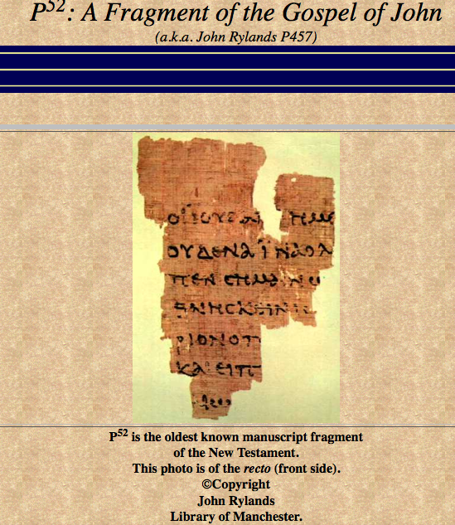
In 1920, Bernard Greenfell acquired some papyri in Egypt. Among them were some small fragments. This 2.5 by 3.5 inch papyrus rested in the collection of the John Rylands Library at Manchester, England until 1934 when a Fellow of St. John’s College at Oxford, C. H. Roberts, began sorting through them. Roberts picked up the fragment and immediately recognized the few Greek lines on the recto (front) and verso (back) as being parts of the Gospel of John 18:31-33 and 37-38 respectively. The fragment is still in the John Ryland Library, for I saw it there when I was in England.
The Paleography (study of ancient writing styles) dated the fragment to the time of Hadrian (117 – 138 CE) within 20 years of the composition of the Greek autograph of the Gospel by its author. The Gospel was written in Ephesus by the apostles John, recorded by the early church historians to be the last living eyewitness of Jesus.
It is significant in that this copy was discovered in Egypt, so far from the site of its original composition (Ephesus or Antioch), which may also be evidence that the Gospel had been around for quite a while, certainly enough time to have been disseminated among Christians in other parts of the Roman World. Such an early copy reduces the chance for errors to creep in due to copy errors. This version may have even been made directly from the original.
The John Rylands Fragment supports the evidence that:
1. The gospels were written within the lifetime of the disciples.
2. The gospels were spread across the known world within a single generation, since the common material of the day (papyrus) allowed for quick, mass distribution across the Roman road system.
3. Such a quick and widespread distribution would prevent myth and legend from developing being inserted into the text. With so many copies floating around, any one copy could be easily compared to another for accuracy.
4. Such an early copy would reduce the chance for copy errors to be inserted in the next over time. With a copy made within one generation of the original autograph, the whole idea of errors being introduced from person to person as it is copied becomes an idea with no basis.
Therefore, this John Rylands Fragment, and the other more complete documents such as the Bodmer Papyri, Codex Siniaticus, and Codex Alexandrinus, provide very strong evidence that the gospels were written by eyewitnesses in the first century, and the gospels were accurately copied and distributed to all the known world within a single generation. https://humblesmith.wordpress.com/2010/12/05/evidence-against-myth-legend-copy-errors-the-john-ryland-fragment/

