JOHN THE BAPTIST

(from Biblos Foundation website)
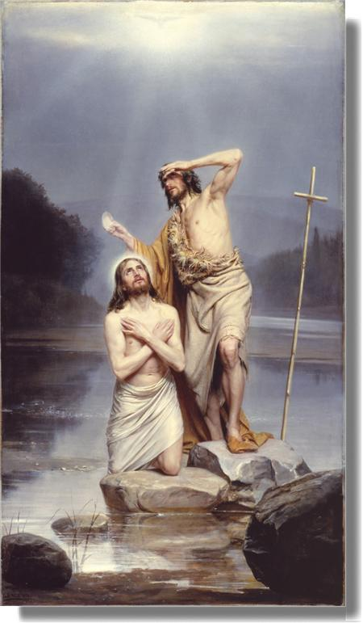John the Baptist is portrayed in the Gospels as the forerunner of the Messiah. His role was in prophecy and his spiritual purpose was to prepare the nation of Israel for the coming of the one who was expected to save Israel.
Prophecies of John the Baptist in the Old Testament:
Mal. 3:1
1 Behold, I will send my messenger, and he shall prepare the way before me: and the Lord, whom ye seek, shall suddenly come to his temple, even the messenger of the covenant, whom ye delight in: behold, he shall come, saith the Lord of hosts.
Mal. 4:5, 6
5 Behold, I will send you Elijah the prophet before the coming of the great and dreadful day of the Lord:
6 And he shall turn the heart of the fathers to the children, and the heart of the children to their fathers . . .
Isa. 40:3
The voice of him that crieth in the wilderness, Prepare ye the way of the Lord, make straight in the desert a highway for our God.
John’s birth was unique in itself. His father Zacharias, a priest in the Temple in Jerusalem, and his mother Elisabeth, a daughter of the priestly tribe of Aaron, were advanced in years and had no children. Elisabeth was, perhaps, a cousin of Jesus’ mother Mary, which, if true, would make John the second cousin of Jesus. Elisabeth was older than Mary, too old for child-bearing (IDB 2.955).
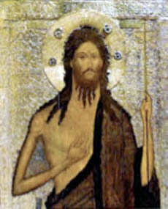Luke 1:6,7
6 And they were both righteous before God, walking in all the commandments and ordinances of the Lord blameless.
7 And they had no child, because that Elisabeth was barren, and they both were now well stricken in years.
“To be childless brought sorrow and often shame. At her advanced age, Elizabeth could no longer entertain the hope of each Jewish woman to be the mother of the Messiah. While her situation and the subsequent intervention of God had its precedents in the Old Testament (Sarah, Gen. 17:16-17; Hannah, I Sam. 1:5-11), no other woman had such a total reversal in fortune as to bear the forerunner of the Messiah” (EBC 8.825).
Zacharias had been told in a vision by the angel Gabriel, while he was working at the altar of incense in the Temple, that he and Elisabeth would bear a son and name him John. The angel predicted that John “shall be great in the sight of the Lord . . . and he shall be filled with the Holy Ghost . . . and many of the children of Israel shall he turn to the Lord their God” (Luke 1:15,16). Zacharias was doubtful and asked questions of the angel, and thus he was made dumb, and was not able to speak out loud until his son was born and later circumcised in the Temple.
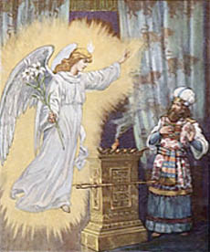The Gospels don’t include very much about John’s early years. Some scholars speculate that he might have spent time with the Essenes, an ascetic, monastic community of strict Jews, located near Qumran.
As John grew, he began to preach near the River Jordan, near Jericho, calling for Israel to repent of their sins, telling them that God’s judgment was coming and they needed to be ready. (Matt. 3:7-11; Luke 3:7-9, 16-17).
Multitudes of people began coming to hear John and to be baptized in the waters of the Jordan River (Matt. 3:5,6). John lived as the prophets of old, wearing animal skins, eating wild honey and locusts, and the people began to claim that he was the prophet who was to come.
John gained a large following of disciples and it is possible that a few of Jesus’ disciples first followed John. Andrew, Peter’s brother, and young John, were two disciples that might previously have been followers of John the Baptist.
One day Jesus appeared and asked to be baptized by John. John tells him he is not worthy to do this. Jesus responds: “Suffer it to be so now,” and when Jesus is baptized a spirit descends on Jesus like a dove and those around him hear God’s blessing: “This is my beloved son, in whom I am well pleased” (Matt. 3:17). This is the first time in four hundred years that the “spirit” returns to Israel.
John then refers to Jesus as the “Lamb of God” (John 1:29-34). John’s role begins to decrease while Jesus’ role increases (John 3:22-36).
After preaching against King Herod II because he had married his brother’s wife, an illegal act, John was arrested. Herod had him imprisoned in a fortress called Macherus on the eastern side of the Dead Sea. While in prison, John sent word to Jesus, asking him if he was the one who was to come, the Messiah. Jesus responds by letting his works be his witness (Matt. 11:2-6). He also tells his disciples that there is no greater son of woman than John (Matt. 11:11), calling him “a burning and a shining light” (John 5:35).
John’s influence did not fade when he was executed. A community of his followers lived long after him probably writing and retelling the stories of John. The historian Josephus tells an account of John the Baptist that was eventually left in the writings of Origen and Eusebius, two early Christian scholars of the third and fourth centuries.
Josephus, an early historian of the Jews (38 C.E. to 100 C.E.), writes the following about John the Baptist:
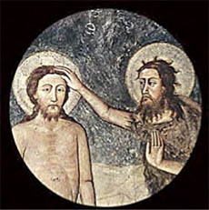“Now some of the Jews thought that the destruction of Herod’s army came from God, and that very justly, as a punishment of what he did against John, that was called the Baptist: for Herod killed him, who was a good man, and commanded the Jews to exercise virtue, both as to righteousness towards one another, and piety towards God, and so to come to baptism; for that the washing (with water) would be acceptable to him, if they made use of it, not in order to the putting away (or the remission) of some sins (only), but for the purification of the body; supposing still that the soul was thoroughly purified beforehand by righteousness. Now when (many) others came in crowds about him, for they were very greatly moved (or pleased) by hearing his words, Herod, who feared lest the great influence John had over the people might put it into his power and inclination to raise a rebellion, . . . thought it best, by putting him to death, to prevent any mischief he might cause, and not bring himself into difficulties by sparing a man who might make him repent of it when it would be too late. Accordingly he was sent a prisoner, out of Herod’s suspicious temper, to Macherus, the [castle] I before mentioned, and was there put to death. Now the Jews had an opinion that the destruction of this army was sent as a punishment upon Herod, and a mark of God’s displeasure to him” (Josephus 18.5.2).
Eusebius, quoting Josephus, provides further details regarding John’s death:
“Now to some of the Jews it seemed that the army of Herod had been destroyed by God and that he was paying a very just penalty for John who was called the Baptist. For Herod killed him, a good man and one who commanded the Jews, training themselves in virtue, to practice righteousness towards one another and piety towards God, and to come together for baptism. For he said that baptism would prove acceptable to him only in those who used it not to escape from any sins but for bodily purity, on condition that the soul also had been previously cleansed thoroughly by righteousness. . . . [Herod] therefore considered it much better, before a revolt should spring from John, to put him to death in anticipation, rather than be involved in difficulties through the actual revolution and then regret it. And John, through Herod’s suspicion, was sent a prisoner to Macherus, the prison mentioned already, and was there put to death” (Eusebius 2:81).
Sources:
Eusebius. The Ecclesiastical History. Trans. Kirsopp Lake. Vol. 1. Cambridge: Harvard University Press, 1980.
The Expositor’s Bible Commentary: Matthew, Mark, Luke. Ed. Frank E. Gaebelein et al. Vol. 8. Grand Rapids: Zondervan, 1984.
The Interpreter’s Dictionary of the Bible. Ed. George Arthur Buttrick et al. Nashville: Abingdon, 1989.
Josephus. Complete Works of Josephus. William Whiston, trans. Grand Rapids: Kregel Publications, 1981.
Roff, Ida Mitchell. “Baptism and Communion.” The Christian Science Journal 30, No. 2 (May 1912): 89-94.
Walker, Peter. In The Steps of Jesus. Oxford: Lion Hudson, 2007.

