Research on: The Parable of the Tares and the Wheat

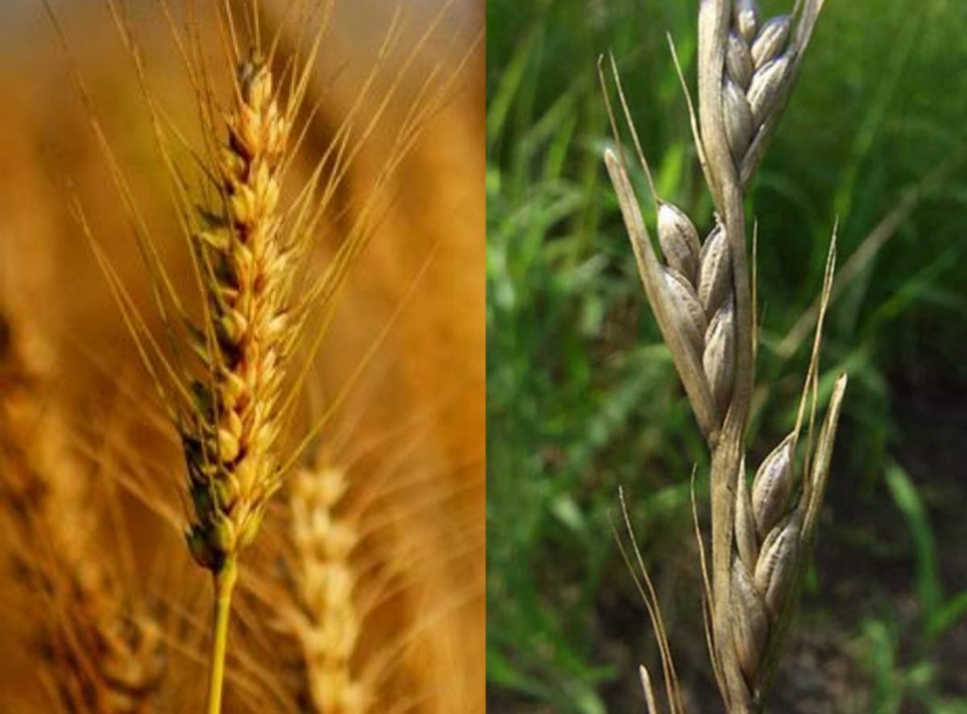

Matthew 13:24-30

Parables: Mary Baker Eddy states in Science and Health with Key to the Scriptures:
117:15-16 “Our Master taught spirituality by similitudes and parables.”
Parable in Greek is parabole which means “a placing of one thing by the side of another, juxtaposition, as of ships in battle; comparing, comparison, an example by which a doctrine or precept is illustrated; an earthly story with a heavenly meaning; likeness; similitude” (www.blueletter.org, Strong’s 3850).
“This [chapter in Matthew] introduces a new type of teaching, that by parables. St. Matthew gives us a group of seven, the first four of which (the Sower, the Tares, the Mustard Seed, the Leaven) were addressed to the multitudes, and the last three (the Hid Treasure, the Pearl, and the Draw-net) to the disciples.
“St. Matthew’s group of seven forms ‘a great whole, setting forth the mystery of the kingdom in its method of establishment, its corruption, its outward and inward growth, the conditions of entrance into it and its final purification.’
“St. Matthew and St. Mark both agree that Jesus did not begin to teach regularly in parables until opposition to his teaching had developed, and the people under the influence of the Pharisees and scribes had begun to harden themselves against his influence, and to criticize his doctrine. One purpose of his parabolic teaching was to conceal his doctrine from the unfit as a punishment for their willful blindness and spiritual unreceptiveness. But the parables also served to reveal the truth in suggestive and stimulating forms to the fit” (Dummelow 671).
24 Another parable put he forth unto them, saying, The kingdom of heaven is likened unto a man which sowed good seed in his field:
“The seed of Truth and the seed of error, of belief and of understanding, — yea,
the seed of Spirit and the seed of matter, — are the wheat and tares which time will separate, the one to be burned, the other to be garnered into heavenly places” (S&H 535:1).
“That is, the "gospel resembles." The kingdom of heaven (see the notes at Matthew 3:2) means here the effect of the gospel by its being preached. The meaning of this parable is plain. The field represents the "world," in which the gospel is preached. The "good seed," the truths preached by Christ and his apostles” (Barnes 64).

“Sow in Greek is speiro which means “to sow, scatter seed, metaph. Of proverbial sayings” (Strong’s 4686, www.blueletterbible.org).

25 But while men slept, his enemy came and sowed tares among the wheat, and went his way.
“Slept in Greek is katheudo which means “fall asleep, drop off to sleep, metaph. To yield to sloth and sin, to be indifferent to one’s salvation” (Strong’s 2518, www.blueletterbible.org).
“While men slept. That is, in the night, when it could be done without being seen, an enemy came and scattered bad seed on the new-ploughed field, perhaps before the good seed had been harrowed in. Satan thus sows false doctrine in darkness” (Barnes 64)
“Enemy in Greek is echthros which means “hated, odious, hostile, opposing another, opposing God in the mind, a man that is hostile” (Strong’s 2189).
“TARES. Mortality; error; sin; sickness; disease; death” (S&H 595:5).
“Tares. ‘Or bastard wheat’: so much like true wheat, that until the corn is in the ear the two cannot be distinguished. Hence any attempt to root up the tares would result in rooting up the wheat also” (Dummelow 673).
“His enemy came and sowed tares.—The act described was then—and still is—a common form of Eastern malice or revenge. It easily escaped detection. It inflicted both loss and trouble. The “enemy” had the satisfaction of brooding for weeks or months over the prospect of the injury he had inflicted, and the vexation it would cause when discovered. The tares, known to botanists as the Lolium temulentum, or darnel, grew up at first with stalk and blade like the wheat; and it was not till fructification began that the difference was easily detected. It adds to the point of the parable to remember that the seeds of the tares were not merely useless as food, but were positively noxious” (Ellicott’s Commentary, www.biblehub.com).

26 But when the blade was sprung up, and brought forth fruit, then appeared the tares also.
“Sleeping does not imply that the servants were neglectful but that the enemy was stealthy and malicious. What he sowed was zizania (“weeds”) almost certainly bearded darnel which is botanically close to wheat and difficult to distinguish from it when the plants are young. The roots of the two plants entangle themselves around each other; but when the heads of grain appear on the wheat, there is no doubt which plant is which” (EBC 8.316).
"The tare abounds all over the East, and is a great nuisance to the farmer. It resembles the American "cheat (chess)," but the "head" does not droop like cheat, nor does it branch out like oats. The grain, also, is smaller, and is arranged along the upper part of the stalk, which stands perfectly erect. The "taste" is bitter, and when eaten separately, or even when diffused in ordinary bread, it causes dizziness, and often acts as a violent emetic. Barn-door fowls also become dizzy from eating it. In short, it is a strong soporific poison, and must be carefully winnowed, and picked out of the wheat grain by grain, before grinding, or the flour is not healthy. Even the farmers, who in this country generally "weed" their fields, do not attempt to separate the one from the other. They would not only mistake good grain for them, but very commonly the roots of the two are so intertwined that it is impossible to separate them without plucking up both” (Barnes 64).

27 So the servants of the householder came and said unto him, Sir, didst not thou sow good seed in thy field? from whence then hath it tares?
“The temporal and unreal never touch the eternal and real. The mutable and imperfect never touch the immutable and perfect. The inharmonious and self-destructive never touch the harmonious and self-existent. These opposite qualities are the tares and wheat, which never really mingle, though (to mortal sight) they grow side by side until the harvest; then, Science separates the wheat from the tares, through the realization of God as ever present and of man as reflecting the divine likeness” (S&H 300:13).

28 He said unto them, An enemy hath done this. The servants said unto him, Wilt thou then that we go and gather them up?
“The owner forbids his servants from attempting to separate weed from wheat till the harvest. Then, as the workers reap the field, only the wheat will be gathered; the weeds, apparently so plentiful they must first be gathered up and burned—it will contaminate the wheat no longer” (EBC 8.316).
29 But he said, Nay; lest while ye gather up the tares, ye root up also the wheat with them.
“Ye root up also the wheat. They so much resembled the true wheat, that even then it would be difficult to separate them. By gathering them, they would tread down the wheat, loosen and disturb the earth, and greatly injure the crop. In the harvest it could be done without injury” (Barnes 64).
30 Let both grow together until the harvest: and in the time of harvest I will say to the reapers, Gather ye together first the tares, and bind them in bundles to burn them: but gather the wheat into my barn.
“Science separates the tares and wheat in time of harvest” (S&H 207:18).
“Mortal belief (the material sense of life) and immortal Truth (the spiritual sense) are the tares and the wheat, which are not united by progress, but separated” (S&H 72:13).

“The tares and the wheat may grow together, but the kernel of the tare can never become a kernel of wheat” (Tomlinson 111).
“The tares and wheat appear to grow together until the harvest; then the tares are first gathered, that is, you have seasons of seeing your errors—and afterwards by reason of this very seeing your tares are burned, the error is destroyed. Then you see Truth plainly and the wheat is ’gathered into barns’ in other words, it becomes permanent in the understanding” (WKMBEX, Reminiscence of Frank Gale, CSD, 217).

