Pamphlet on Ps 23

https://jsh.christianscience.com/collections/2010s/living-the-lord-s-prayer-a-selection-of-timeless-articles

TABLE OF CONTENTS

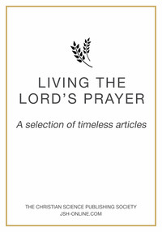
- 'OUR FATHER ...' By AL CARNESCIALI From the January 2007 issue of the Christian Science Sentinel
- "HALLOWED BE THY NAME" By GRACE M. PUTNAM From the December 1923 issue of the Christian Science Sentinel
- "THY KINGDOM COME" By Nathan A. Talbot From the December 1977 issue of the Christian Science Sentinel
- "THY WILL BE DONE" By GENEVIEVE P. OLSON From the September 1925 issue of the Christian Science Sentinel
- "GIVE US THIS DAY OUR DAILY BREAD." By BARBARA COOK From the September 1982 issue of the Christian Science Sentinel
- "AS WE FORGIVE OUR DEBTORS" By CAROBETH LAIRD From the May 1942 issue of the Christian Science Sentinel
- "LEAD US NOT INTO TEMPTATION" By GLADYS ELLA GIBBS From the November 1956 issue of the Christian Science Sentinel
THINE IS THE KINGDOM By IRVING C. TOMLINSON From the September 1907 issue of the Christian Science Sentinel

