When Jesus was asked by the lawyer, which is the great commandment in the law, he quotes from Deut. 4:6, the shema and from Lev. 19:18 – love thy neighbor as thyself.

What is the Shema?

Deut. 6:4
Hear, O Israel: The Lord our God is one Lord:
Deut. 6:5
And thou shalt love the Lord thy God with all thine heart, and with all thy soul, and with all thy might.

SHEMA (Heb. šĕmaʿ)
The foundational statement of Jewish belief: “Hear, O Israel, Yahweh our God, Yahweh is one” (Deut. 6:4). The name derives from the first Hebrew word in the verse, the command to “hear.” The declaration that “Yahweh is one” rules out local manifestations of Yahweh, but also connotes Yahweh’s exclusiveness. Thus, although “alone” is an inaccurate translation of Heb. ʾeḥāḏ (“one”), the assertion of unity contains within it the idea of uniqueness. In Hebrew manuscripts, the last letters of the first and last words are written larger than the others to form the word ʿēḏ (“witness”), reflecting the verse’s testimony to the uncompromising monotheism of Judaism. It has been the final utterance of Jewish martyrs throughout history.
The prayer came to include Deut. 6:4-9; 11:13-21; Num. 15:37-41, and is recited in the morning and evening (cf. Deut. 6:7). The text of Deut. 6:4-9 is placed inside phylacteries, bound to the forehead and arm during prayer, and in a mezuzah attached to the entrance of houses (cf. vv. 8–9). Jesus identified Deut. 6:5 as the greatest commandment (Mark 12:29).
John L. McLaughlin

Mezuzah: has the shema on it and is fixed on every doorframe in Jewish homes
- this is being obedient to the passage that says ‘inscribe the words of the Shema on the knobposts of your house”
- some Jews put one on every door in their house
- sample of two mezuzahs are below. Inside is the Shema, and it goes on the doorpost of a Jewish home.
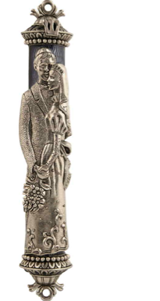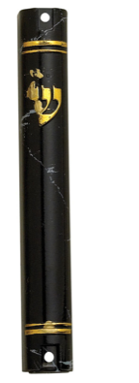

phylactery:

In Judaism. either of two small, black, leather cubes containing a piece of parchment inscribed with verses 4–9 of Deut. 6, 13–21 of Deut. 11, and 1–16 of Ex. 13: one is attached with straps to the left arm and the other to the forehead during weekday morning prayers by Orthodox and Conservative Jewish men.

