Standing Porter

- Read S&H 392:24 “Stand porter at the door of thought.” (There is also a Sentinel article called “Guarding the Castle Gate,” by Kathryn Merrill)
- Briefly share the responsibility of a porter.
- On a piece of paper or cardboard, prepare a castle door: upon a separate sheet of paper, prepare a “DO NOT enter sign.
- Prepare slips of paper with good thoughts and bad thoughts. Students pick a paper and determine if the thought can go through the castle door or on the DO NOT Enter paper.
- Follow up with students taking turns to be the porter: standing with their hands out, each student needs to give the porter a thought (good or bad) and the porter needs to decide whether to let the thought in.
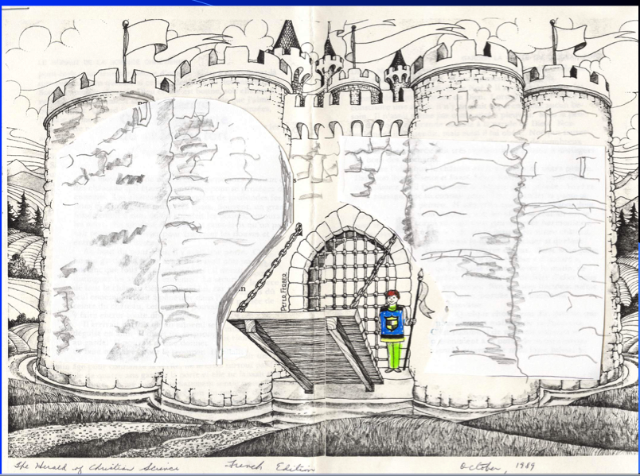
DO NOT ENTER!

