Synagogue

The word “synagogue” means “congregation” or “assembly.” Some scholars believe that the first synagogues were erected during the Babylonian Captivity (sixth century BCE), when Jews no longer had the Temple in which to pray and to teach. Ten men could form a synagogue. A Pharisee was in charge of the services. By 70 CE, 480 synagogues were in Jerusalem. Each one consisted of a house for reading the Law and a place where school children received their elementary instruction.
All synagogues were destroyed when Rome destroyed the Temple in Jerusalem in 70 CE.
Services on the Sabbath consisted of readings from the Scriptures—the Law and Prophets. Services always began with the shema: “Hear, O Israel, the Lord our God is one Lord; and thou shalt love the Lord thy God with all thine heart, and with all thy soul, and with all thy might” (Deut. 6:4). The text was read in Hebrew, but most Jews during Jesus’ time spoke Aramaic, so an interpreter gave a verse-by- verse explanation (a targum).
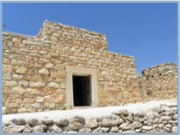
Synagogue at Nazareth Village ©2010. Biblos Foundation.

The furnishings in the synagogue consisted of:
• The Torah shrine, where one or more Torah scrolls and probably some prophets’ scrolls were kept. It was a chest (sometimes called an “ark”) covered and screened from the sight of the congregation by a veil or curtain. In the center was the bema, or elevated podium, for reading of the lessons and benedictions.
• The Menorah, the seven-branched candlestick or lampstand located in the large assembly room. • Stone benches, rather than chairs, lined the walls. Women and children sat upstairs in a gallery separate from the men.
The synagogue was open three times a day for prayer. The Torah was read in its entirety once every three years. It was customary to invite any stranger who happened to attend the services to deliver a prophetic lesson. Ten elders chose a head of the synagogue.
How did the synagogue differ from the Temple? There were no animal sacrifices, no altar, no priests.
Synagogue at Nazareth Village ©2010. Biblos Foundation.
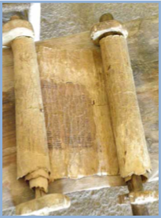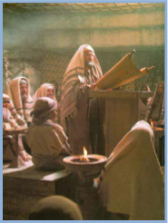
Reading from the Torah in the Synagogue (photo still from Jesus of Nazareth film) © 1977. Paul Ronald.

