ARK OF THE COVENANT:

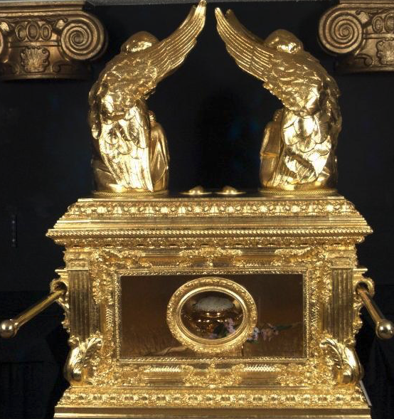

The Ark of the Covenant was a sacred chest built by the Israelites, under exact specifications given to them by God. It included a pledge by God that he would dwell among his people and give them guidance from the mercy seat on the top of the Ark.

Special care was taken on the lid: solid gold with two hammered gold cherubim, or angels, on it, facing each other, with their wings overshadowing the lid. God told Moses:
"There, above the cover between the two cherubim that are over the ark of the Testimony, I will meet with you and give you all my commands for the Israelites." (Exodus 25:22, NIV)
God told Moses to place the tablets of the Ten Commandments inside the Ark. Later, a pot of manna and Aaron's staff were added.

During the Jews' wanderings in the desert, the Ark was kept in the tabernacle tent and was carried by priests of the Levite tribe as the people moved from place to place. It was the most important piece of furniture in the wilderness tabernacle. When the Jews entered Canaan, the Ark was usually kept in a tent, until Solomon built his temple in Jerusalem and installed the Ark there with a solemn ceremony.
Once a year the high priest made atonement for the people of Israel by sprinkling the mercy seat on top of the Ark with the blood of sacrificed bulls and goats. The term "mercy seat" is associated with the Hebrew word for "atonement." The lid of the Ark was called a seat because the Lord was enthroned there between the two cherubim
https://www.thoughtco.com/ark-of-the-covenant-700738

From The Wycliffe Bible Dictionary:

ARK OF THE COVENANT. This was a chest made of acacia wood, about four feet long, two and a half feet wide, and two and a half feet high. It was overlaid with gold inside and out (Ex 25:11) and a ring of gold at each corner or foot through which poles were passed to carry it. The lid of the ark, the kappo„reth or “mercy seat” (Ex 25:17), was made of pure gold. At each end of the mercy seat was a cherubim made of hammered gold.

The ark (áa„ro„n) is referred to some 200 times in the OT under 22 different designations. It is called the ark (Ex 25:14), the ark of Jehovah (I Sam 4:6, ASV), the ark of God (Elohim, (I Sam 4:18), the ark of the covenant (Josh 3:6), the ark of the testimony (Ex 25:22). This various terminology for the ark may reflect a difference in date and authorship of the various sources, but this is not necessarily so.

The ark seems to have served various functions during its history. It was built by Moses (Deut 10:5), or actually by Bezaleel (Ex 31:2, 6–7; 37:1–9), at Sinai. According to Num 10:33–36 it served as a guide to Israel in the wilderness, and Num 14:44 adds that when the rebels at Kadesh-barnea went out to possess the Promised land, neither Moses nor the ark went with them. In these passages the ark serves as a symbol of the presence of God. The ark is spoken of as the throne of God (I Sam 4:4; II Sam 6:2; cf. Jer 3:16).

The idea of the ark as a war palladium is a very common one in the OT. The ark was very prominent in the story of the capture of Jericho (Josh 6–7), and in the struggle with the Philistines when the ark was captured (I Sam 4:11), at which time it is said that “the glory is departed from Israel” (I Sam 4:21). Even in defeat God did not abandon His throne on the ark but wrought havoc among the Philistine captors. The power of the ark can be seen in the curses it brought upon the Philistines (I Sam 5) and upon Uzzah (II Sam 6:7). G. Henton Davies has urged that the ark may be mentioned a number of times in the Psalms under the term `oz, “strength” (cf. “The Ark in the Psalms, Promise and Fulfillment”, F.F. Bruce, ed.; also cf. Ps 132:8; 78:59–61; 105:4).

One other function of the ark was to serve as the container of the tablets of the law or covenant. This concept is reflected in the name “the ark of the testimony” (Ex 25:16; Num 4:5; Josh 4:16).

When the ark was returned from the Philistines, it came to Beth-shemesh (q.v.) and then was removed to the house of Abinadab in Kirjath-jearim where it stayed for approximately 20 years, (I Sam 7:2). Although the ark was now in Israel, it was probably, in effect, still under the control of the Philistines. This fact would explain why Saul had nothing to do with the ark and why “all the house of Israel lamented after the Lord” (I Sam 7:2). [Pfeiffer, Charles F., Wycliffe Bible Encyclopedia, (Chicago, IL: Moody Press) 1975.]

