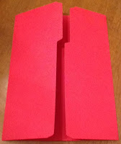
Today is a 10 Commandment file Folder Game (FFG). It will work best if you have a folder with the tab at the top (first pic). I print everything on cardstock, and use Tacky glue to glue it.
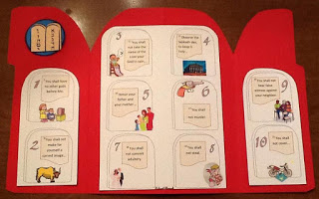
Here is where you have a choice. This is the basic finished inside. You can choose
(1) to have blank numbered stones and cut and glue the scripture and graphic to the correct one. Print it here.

(2) You just cut and glue the scripture (The graphic is already with the correct number). You can also use the 10 commandments stickers (instead of the printable scripture) from Oriental Trading. You can print this option here.
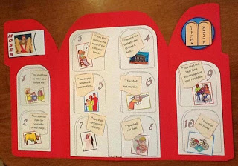
And (3) You can add a pocket and play it like a game so you can reuse the parts. When you are finished sorting and playing the game, all the parts are stored in the pocket. The pocket needs to be glued at the top with the largest section. (see photo) You can print this
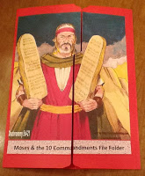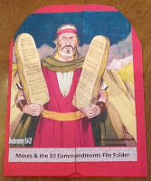
Once that is done, cut and glue on the front cover. It should look like the above photo. Next, I used a round plate (or whatever) to round off the edge. (comes from “Bible Fun For Kids)

